Aim
To design and deploy a Flight Reservation System as a cloud-based SaaS application using a cloud service provider (Zoho Creator), where users can search for flights, book tickets, and manage reservations.

Procedure
Step 1: Login to Cloud Provider
- Open Zoho Creator and sign in with your Zoho account.
Step 2: Create a New Application
- Click Create Application → From Scratch.
- Name it: Flight Reservation System.
Step 3: Build Forms (Data Entry)
- Flight Details Form
  - Flight Number
  - Airline Name
  - Source Airport
  - Destination Airport
  - Date (Date Picker)
  - Departure Time (Time Picker)
  - Arrival Time (Time Picker)
  - Available Seats (Number)
- Passenger Booking Form
  - Passenger Name (Text)
  - Email (Email)
  - Phone Number (Phone)
  - Flight (Lookup from Flight Details Form)
  - Number of Seats (Number)
Step 4: Create Reports (Data Views)
- Available Flights Report → List all flights with available seats.
- Booking Report → Show passenger reservations.
- Apply filters so passengers can search by Source, Destination, and Date.

Step 5: Add Workflow (Automation with Deluge Script)
- When a booking is made:
  - Reduce the number of available seats in the selected flight.
  - Send a confirmation email to the passenger.

Flight Reservation SaaS Application:

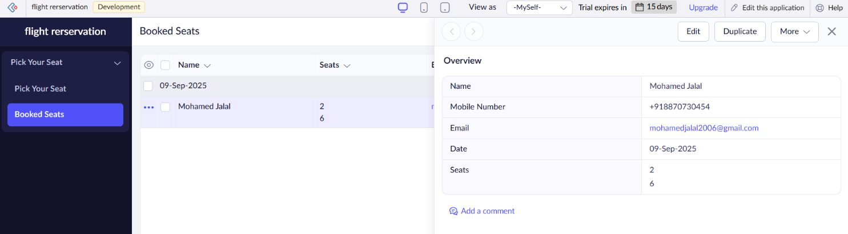

Result
- A Flight Reservation SaaS Application was successfully created and deployed using Zoho Creator.
- Passengers can search flights, book seats, and receive booking confirmations.
- The app automatically updates seat availability.
- The system is hosted on Zoho’s cloud and accessible worldwide via a web link, demonstrating Software as a Service (SaaS).

